RESOLUTION NO.__________

RE: CERTIFICATE OF APPROPRIATENESS UNDER THE
PROVISIONS OF THE ACT OF THE PENNSYLVANIA
LEGISLATURE 1961, JUNE 13, P.L. 282 (53
SECTION 8004) AND BETHLEHEM ORDINANCE NO.
3952 AS AMENDED.

WHEREAS, the applicant is proposing to install solar panels on the roof at 407 Center St.

NOW, THEREFORE, BE IT RESOLVED by the Council of the City of Bethlehem that a Certificate of Appropriateness is hereby granted for the proposal.

Sponsored by: (s)

(s)

ADOPTED BY COUNCIL THIS DAY OF

(s)
President of Council

ATTEST:

(s)
City Clerk

HISTORICAL & ARCHITECTURAL REVIEW BOARD

The applicant is proposing to install solar panels on the roof at 407 Center St.
APPLICATION #3:

George & Karen White
407 Center St.
Bethlehem, PA 18018

OWNER:

__________________________________________________________________________

The Board upon motion by Beth Starbuck and seconded by Marsha Fritz adopted the proposal that City Council issue a Certificate of Appropriateness for the following:

1. To install 9 total solar panels not visible from below.

2. The motion was unanimously approved.

__________________________________________________________________________

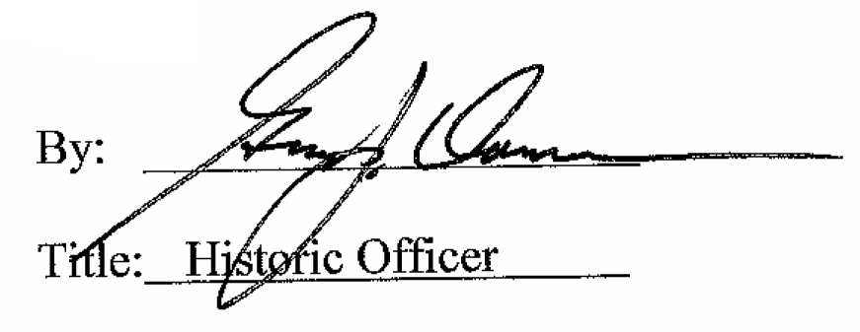

Date of Meeting: July 5, 2017

